Life at sea Homework project
Homework task:
It’s your task to create a Treasure Island exhibit.
You can make your model out of any materials for example: Lego, clay, or if you prefer you could design it on the computer using something like Minecraft, you could even make it out of cake!
With your 3D model I would like you to complete 3 of the additional tasks on the back of the sheet.
Please hand in your exhibit by Wednesday 8th February.
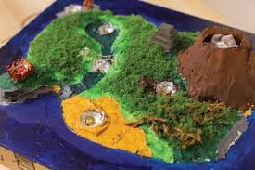
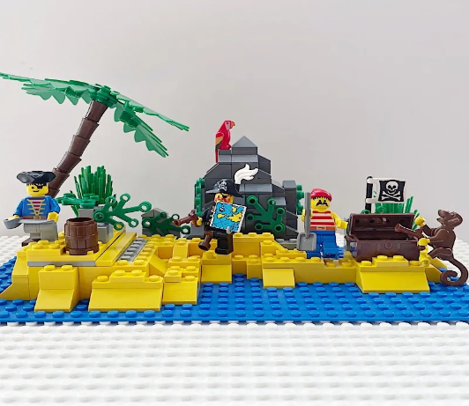

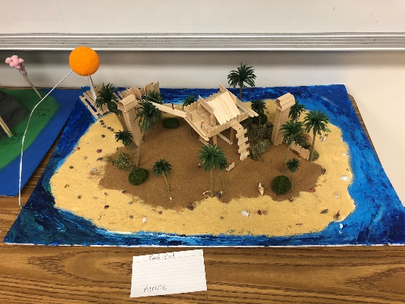
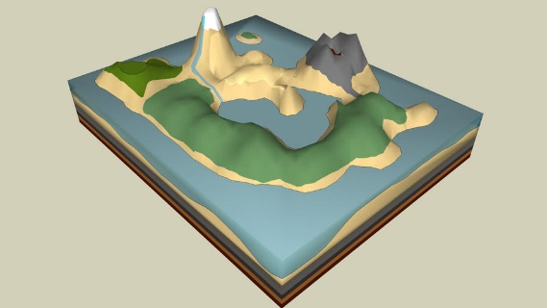

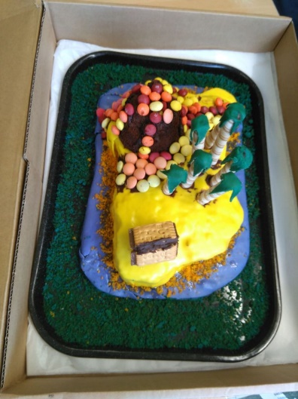

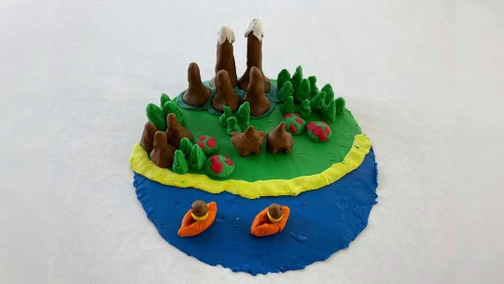

Activity 1:
Write diary entries for Jim Hawkins, Captain Smollet and Squire Trelawney. Use them to describe their contrasting feelings about Long John Silver and the crew.

Activity 2:
Draw up the list of stocks that you think was being loaded on to the Hispaniola. What is mentioned in the text and what are the other things that you might imagine were loaded up?
Activity 3:
The pirate attack of the inn has been reported in the local newspaper. Create an eye-catching newspaper front-page report about the raid and what happened to the pirates afterwards. Remember the 5Ws and 1H (who, what, when, where, why and how).

Activity 4:
Imagine that the pirates have taken over the Admiral Benbow Inn for themselves and given it a new name. What do you think it would be? Design a new inn sign and include the name.

Activity 5:
Squire Trelawney went to Bristol to buy a ship and now needs a crew to sail it. Help him write a job advert. What eye-catching heading could he use? Where is the ship going? Does he mention the treasure? What skills is he looking for?

Activity 6:
Many ships of the past had decorated wooden figureheads attached to their bow (front). Design one for the Hispaniola.

Activity 7:
Long John Silver was known to be a great cook. Write out a menu for breakfast, lunch and supper on the first day at sea. You may need to do one for the crew and a different (more posh) one for the captain and his guests.
Or
Cook a meal for the captain and his guests, serve it up, take a photo of it and eat it.

Activity 8:
You are a young pirate on the ship and have discovered a ton of treasure, but it’s on the island and you don’t have a boat. Design and build a raft that will hold as much treasure as possible.

