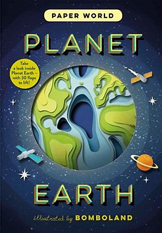

**Science: Our World**

We will be learning about the world and begin to understand its place in the solar system. We will learn about issues facing our world and its inhabitants, and what can be done to protect it. We will also be developing our scientific enquiry skills through investigations related to our environment, including keeping weather observations.

**Geography: The World Around Us**

We will be learning about the different oceans and continents. We will learn key landmarks and countries in each continent, and begin to know where these are in relation to the equator. We will understand where hot and cold countries are in relation to the equator, and understand why we have seasons in Britain. We will also spend time learning about traditions from around the world.

**Art:**

We will be using collaging and multimedia, focusing on creating artwork of landmarks from around the world. We will also be learning about relief sculptures and artists, depicting their own views of the wonderful world.

**English:**

**Unit 1: Question and Answer Texts**

We will be learning the features of question and answer texts, and identify these on example texts. We will be focusing on Neil Armstrong as a class, and then write our own independent question and answer texts about Katherine Johnson. In our grammar we will be particularly focusing on using question marks and capitalising proper nouns. In our writing we will be focusing on using precise verbs, using noun phrases and using the conjunction ‘because’ to add detail.

**Unit 2: Story Writing**   
We will be using ‘My Christmas Star’ as a video stimulus, and discussing the plot and literary techniques used within it. We will use this video to support us in developing our own writing skills. In our grammar we will be particularly focusing on using contractions, comparatives and superlatives, and punctuating accurately with full stops, capital letters and question marks. In our writing we will be focusing on using such skills as alliteration, similes, powerful adverbs and adjectives, and onomatopoeia

**In addition:**

PSHE: Anti-bullying.

PE: Gymnastics and Dance.

RE: Festivals in Christianity.

Music: Jazz, with a focus on Louis Armstrong’s ‘What a Wonderful World’.

Computing:

What a Wonderful World!

Larch Class Autumn 2 Topic Map

**Maths:**

**Addition and subtraction:**

* Adding and subtracting 2-digit numbers.
* Missing number problems.

**Money:**

* Recognising coins and notes
* Counting money in notes, pound coins and pence
* Finding change.

**Multiplication and division:**

* Making and adding equal groups.
* Multiplication as repeated addition.
* Arrays.
* Using the multiplication symbol.