English:

This half term we shall continue to focus on using a variety of sentence types and grammar within our writing. Our fiction focus will be “The Incredible Book Eating Boy” before we look at explanation writing within “The Street Beneath Our Feet” and creative devices in poetry.

Maths

As Mathematicians we will develop our knowledge of the number system. We shall focus on using methods which allow us to add and subtract efficiently before looking at our times tables and how to multiply and divide.

PE

We will focus on hockey skills through a variety of activities which will support our movement, passing and shooting technique.

We will also focus on learning to choreograph a routine which fits in time with a piece of music.

Music

As musicians we will look at learning more notes and rhythms on the glockenspiels before composing our own music.

Art

We shall continue to use our sketching, shading and perspective work to draw faces and figures and begin to add colour to enhance our final piece.

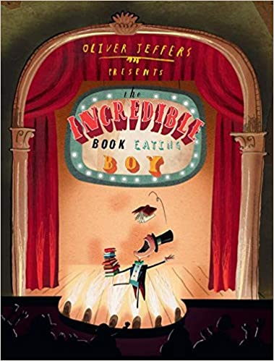

Science

As scientists our focus this half term will be animals including humans. This will focus on nutrition for humans and animals as well as studying food webs and food chains before moving on to taking a closer look at different skeletons and muscles.

PSHE

Throughout discussions and written work, we will look at family and friends as well as anti-bullying and how events can affect emotions.

Topic

As our topic focuses on Food, Glorious Food, we will develop our knowledge of food groups and how food is made. Our main focus will be DT, but we shall also look at animals, Maths and a history of food.

Key Vocabulary: nutrition, carbohydrates, fruit, vegetables, protein, dairy, meat.

RE

We will continue broadening our knowledge of Islam and how art is used within the religion.

Computing

As computer scientists’ we will develop our bug fixing skills through “Scratch”. This will include reading codes and finding the problem before using the solution and fixing it.

Food, Glorious Food

Oak Class

Autumn Two