Speech and Language
at
Stapleford Community
Primary school

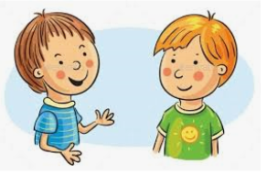

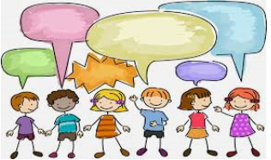

What is in this booklet?

This booklet will hopefully help you to understand Speech and Language and how this looks like in our children.
It will also contain:
What Speech and Language is and why it is so important
What we offer at our school

Information on the different areas and what they mean

Games to play at home

What to do if you are concerned about your child

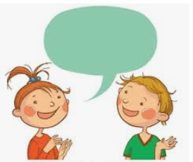

Useful websites

What is
Speech and Language?
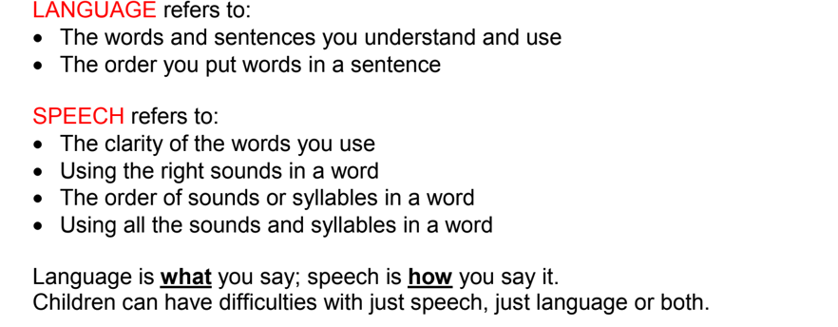

Why is Speech and Language important?
If a child can’t say it, they can’t read it, they can’t write it!

The different areas of
Speech and Language
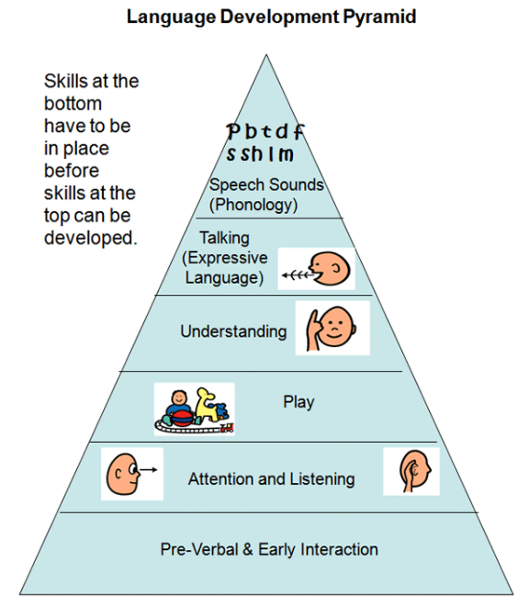

Attention and Listening
Attention and Listening developmental milestones
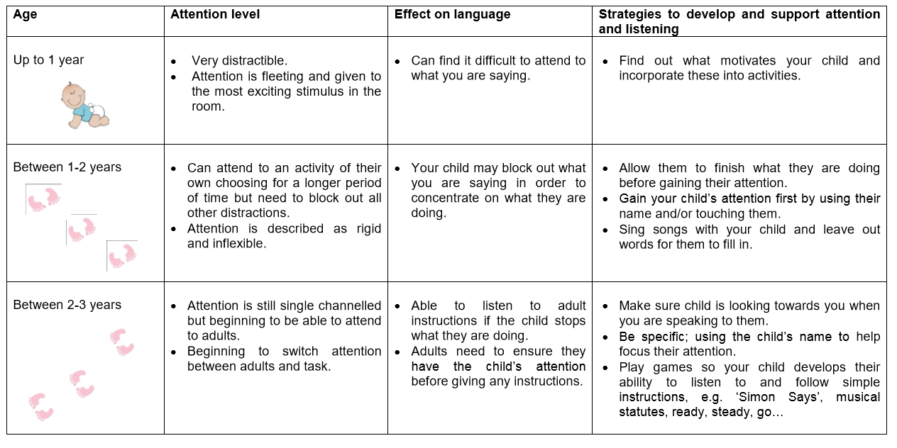
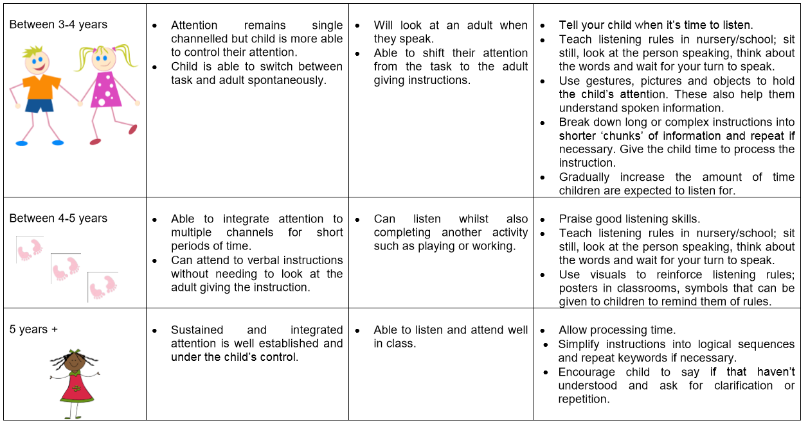
Please look at our website for games to help with Attention and Listening
Play
Why is play important?
Playing isn't just fun, it's also the best way for young children to learn. By playing and talking in play, children can practise all the skills they'll need as they grow.

Children learn from everything they do and everything that's going on around them.

To grow and develop, children need time and attention from someone who's happy to play and talk with them. Children need positive social interactions to be modelled and through play is the most natural way for this to happen.
If you're pressed for time as a parent, it's a good idea to find ways to involve your child in what you're doing – even the housework! And talking with them as you go.

Get your child involved in everyday activities!

Tips for playing and talking to your children:
Get together lots of different things for your child to look at, think about and do.
By making what you're doing fun and interesting for your child, you can get your household jobs done while they're learning.

Give your child plenty of opportunities to use their body by running, jumping and climbing, especially if you don't have much room at home.
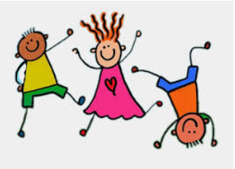

Find other people who can spend time with your child when you really need to focus on something else.
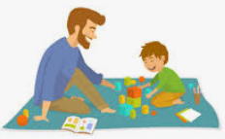

Have times when you focus completely on your child. Talk about anything and everything, even what to put on the shopping list. By sharing as much as possible, your child will pick up lots of new words.

Language
Receptive Language
Expressive Language
Receptive Language
Understanding words and phrases

Why is receptive language important?

Receptive language is important in order for children to communicate successfully. Good receptive language will mean children are able to follow instructions and respond to questions.

What activities can help improve receptive language?
- Name items together when completing tasks
such as when looking at a book, in the car, looking outside, while playing or when shopping.
- Encourage the child to talk about what you do and see and possibly draw or act out what happened
such as when going shopping and visiting places, at the park, zoo or museum
- Model new words when playing
Play activities with the child that they really enjoy and throughout the game model new words and phrases.
- Explain new concepts in different ways
(e.g. looking at the concept of “wet”: use water to wet things and talk about things that are wet and dry; look at pictures of things that are “wet”; if it rains, or the child is in the bath, talk about the concept of being “wet”; make up sentences and stories about being wet/dry).
- Play Simon says
Take turns with the child in following and giving instructions. Also, gradually increase the length of the command that is provided (e.g. ‘Simon says touch your toes’; ‘Simon says first touch your toes, then clap your hands’; ‘Simon says before you shout hurrah, count to 10’). Additionally, reinforce body parts (e.g. pat your head, pull your ear) and simple verbs (e.g. jump, shake) when playing the activity.
- Practice taking turns and following instructions
Put together an obstacle course in the house or outside in the backyard. Take turns with the child in following and giving instructions. Gradually increase the length of the command that is provided (e.g. run to the sandpit; first run to the sandpit then crawl over to the bikes).
- Practice extending talk
Feely bag game: Place different everyday items/objects (e.g. toothbrush, car, cup, block) into a bag. Take turns with the child in taking an item out of the bag. Encourage the child to:
  - Reach into the bag and try to guess what the item is before taking it out.
  - Describe characteristics about the item once they have pulled it out of the bag (e.g. colour, shape, use/function).
  - Answer questions about the item that they have pulled out (e.g. Is it round? Can you eat it?).
  - Guess the item that you have pulled out of the bag by asking you questions (e.g. Is it round? Can you eat it?).
- Read together
Look at picture books with the child. Take turns in asking each other questions about the pictures (e.g. Who is in the picture? What is the girl/boy doing?). Try to think about what might happen next in the story and different possible endings.

Expressive Language
Using words and phrases

Expressive language is a broad term that describes how a child communicates their wants and needs, this can be verbal or non-verbal.

Expressive language skills include: facial expressions, gestures, intentionality, vocabulary, using words/sentences correctly and grammar.
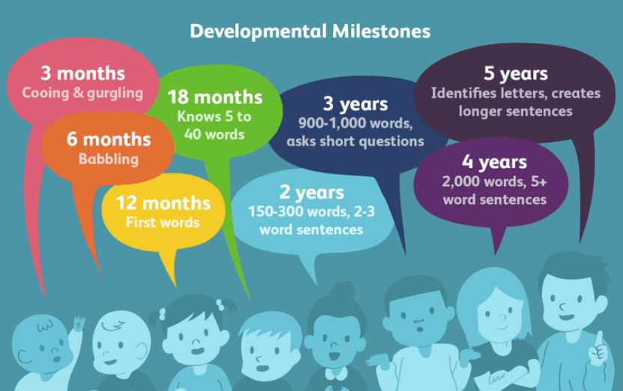

Games to help with expressive language can be found on our website.
Children’s development of speech sounds is a gradual process. Each child is different but most children follow a similar pattern.
Speech Development

Chi

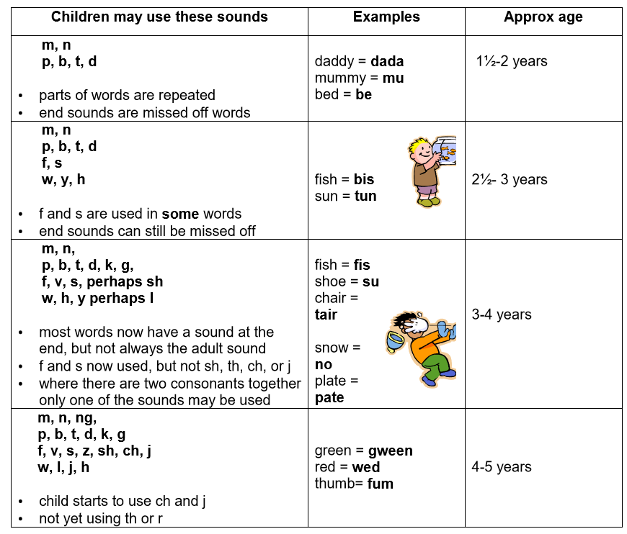
Children start playing with sounds from a very early age. However it takes time and practice in order to use all these sounds correctly in words. Some sounds are more difficult than others and as a result children frequently substitute one sound for another. Eg saying ‘tar’ for ‘car’.

What can I do to help at home?
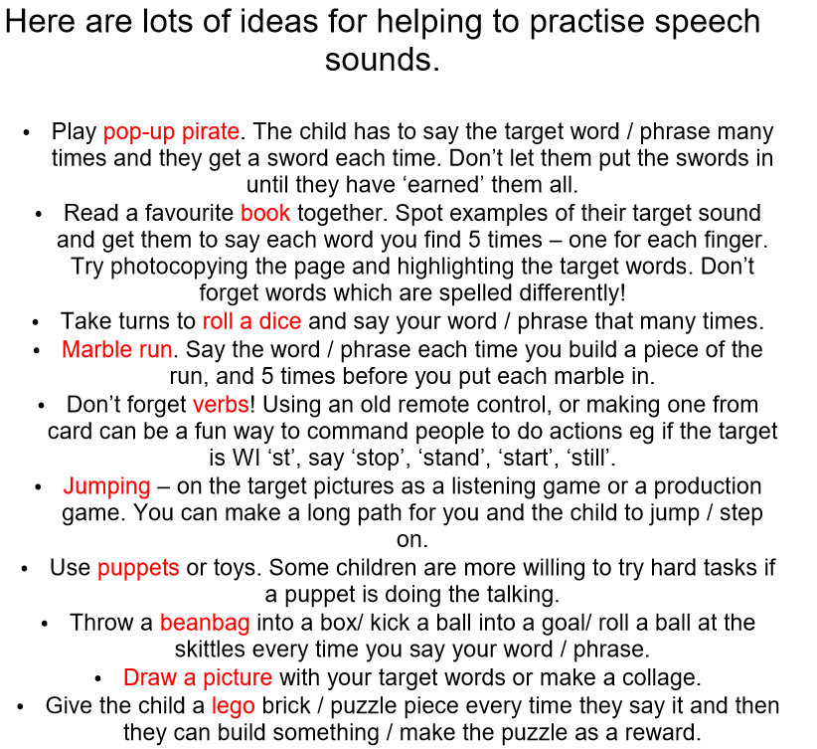
Practise, practice, practice…

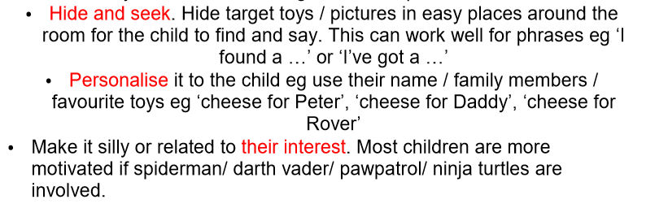

What should I do if I am concerned about my child?
If you have any worries, questions or concerns about your child, please speak to your class teacher in the first instance.
If this doesn’t relieve your worries, please contact the SENDCO, Mrs Wagstaff via the school email:
office@staplefordprimaryschool.org
Useful websites
Child Development
https://childdevelopment.com.au/areas-of-concern/understanding-language/receptive-language-understanding-words-and-language/

Speech and Language Therapy
https://www.cambscommunityservices.nhs.uk/what-we-do/children-young-people-health-services-cambridgeshire/specialist-services/childrens-speech-and-language-therapy

Mom Empower
https://momempower.com/speech-therapy-importance-play/

NHS
https://www.nhs.uk/conditions/pregnancy-and-baby/why-play-is-important/

Follow us on Twitter @Stapleford_CPS

Follow Speech and Language Support on Instagram @SLT_Cambridgeshire

