Homework Menu – Autumn 1: Choose 5 activities to complete before October half term. Bring your book in before half term and we shall look at your homework. Feel free to post photos on Google Classroom, email work to me or bring pieces in throughout the half term!
Write a set of instructions to teach me how to do something you love doing – it could be baking a cake, playing a video game or scoring a goal! | Decorate a big stone or a pebble with a design of your choice. If you can’t find a stone to decorate, create your design in your homework book instead.  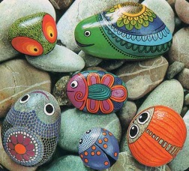  Tell me why you  have chosen  that design!
Complete the attached place value Maths sheet.  Tell you parent about the learning you have been doing so far in Maths. | Create a poster all about starting Year 3.  What new routines or rules did you have to follow?  What was different to Year 2?  What was fun?  Was anything a bit difficult?
Write your own song, rap or poem all about the Stone Age, Iron Age or Bronze Age. | Build a circuit of five different exercises and complete the circuit.  You could video your workout, take photos or draw pictures of yourself completing it.  Make sure to tell me what the five exercises are and I can try them at home!

